Schwarzkopf Elementary PTA
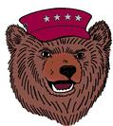
October 8th – 22nd, 2021
BEAR RUN
Adopt-A-Class
We are looking for local businesses and families to ‘Adopt-A-Class’ for our Annual BEAR RUN! The adoption fee is $200. These funds will go directly back to our school to help provide our classrooms with school supplies and additional essential needs.

As a sponsor, you will receive a letter of thanks from your adopted class. An Adoption Certificate with your business/family name will be placed on the classroom door. Your business/family name will be posted on a large banner on our Carline display. Your business/family name will also be added to our sponsor section on our fundraising webpage for the Bear Run. For businesses, a link to your website will be added to your sponsor section!

Yes, I would like to Adopt-A-Class for Schwarzkopf Elementary!

Classroom I would like to Adopt: _____________________________

Business or Family Name: ___________________________________

Address: ________________________________________________

Phone Number: ___________________________________________

Please Contact: ___________________________________________
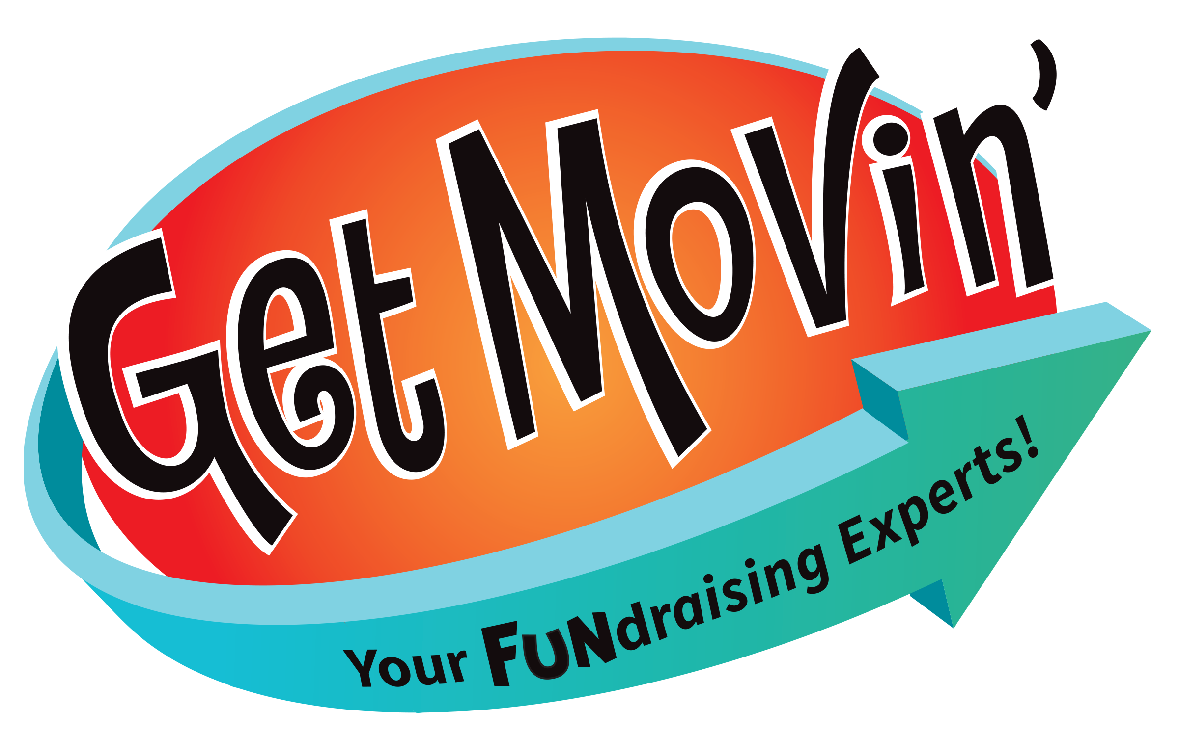
Please make all checks out to:
Schwarzkopf Elementary PTA

